
Unexploded Ordnance Report

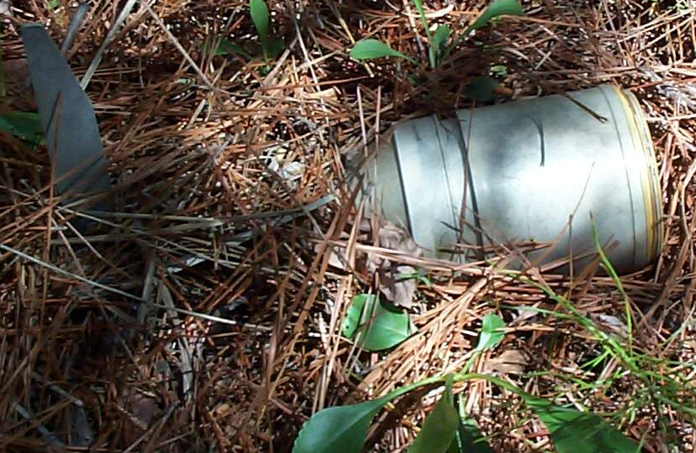
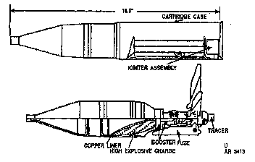

Location: Multi Purpose / Demonstration
UXO Identification: M136 (AT-4) High Explosive Anti Tank Projectile
Depth Recovered: Surface
Condition: Ballistic windshield separated point initiating fuze live base
detonating fuze live
Number of Items: 1 ea.

Description:
The AT-4 consists of a fiberglass reinforced launching tube with a firing mechanism, sight, carrying sling, and protective covers. The recoilless design is superior to the rocket-type weapon for this application. The fin-stabilized cartridge contains the projectile (warhead) and case assembly. The warhead is a shaped charge HEAT projectile with 84mm full caliber fuzing action. Detonation of the Octol explosive charge is achieved with a piezoelectric impact fuze sensitive to impact angles as shallow as ten degrees.

Functioning:
The trigger is pressed releasing the firing rod. The firing rod strikes a pin and ignites the percussion cap that ignites the propellant load. Pressure builds up in the launcher from burning propellant, the plastic base plate breaks and gases exit rearward to balance the launcher recoil. Burning propellant expels the projectile from the launcher. The round hits the target and the shock is transmitted to the piezoelectric base detonating fuze. The fuze train detonates the charge, which collapses the copper liner into a finger-shaped jet. Extremely hot, high velocity gases precede the jet, which melts a hole in the target layer diode to the electric detonator, thus initiating the fuze. The fuze explosive train detonates the shaped charge, which collapses the copper liner into a finger shaped plasma jet. The high velocity jet, at tremendous pressure, melts a hole and penetrates the target. Almost simultaneously the body and standoff cone are blasted into small fragments.

